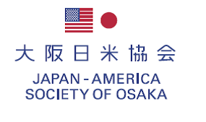

June 3th, 2024

2024 Annual General Meeting and the Reception

Dear Members,

I am pleased to announce that we will hold the 2024 Annual General Meeting on Friday, July 26th, 2024 at RIHGA Royal Hotel Osaka. Among the agendas to be discussed are reports on the activities that took place during the fiscal year of 2023 and event proposals for the fiscal year of 2024.

Following the Meeting, we will have a reception for getting to know new members, mingling with old faces and catching up with the latest news.

I look forward to your participation and seeing you at the event.

Sincerely,

Masashi Kuroda
President
Japan-America Society of Osaka

＊ ＊ ＊
Date & Time: Friday, July 26th, 2024
17：00 Registration desk opens
17：30～18：00 Annual General Meeting
18：00～20：00 Reception
Place: RIHGA Royal Hotel Osaka 2F, “SANRAKU”
Fee: Member \10,000 / non-member \12,000 / American Student member \3,000

Fill in the form below and send back to us via fax or email no later than Wednesday, July 17th, 2024.
Sign-up fee should be paid through bank transfer by Monday, July 1st to Friday, July 19th, 2024.
Please note that the cancelation deadline is on Friday, July 19th, 2024.

Mitsubishi UFJ Bank, Osaka-Eigyobu,
Account no. Futsuu Kouza 0277905, Account name: Osaka Nichibei Kyokai

Fax ： 06-6734-7004 Email : jaso@ichinen.co.jp
Member’s name

Member

If the guest is a member, please check the box.

